Software Requirements Specification

Version 1.0

<<Annotated Version>>

February 07, 2022

University Courses Ecommerce Website

Sew Yong Qi (Team Leader)

Yu Kai Yang

Chiew Chia Yu

Table of Contents

**1. Introduction** 4

**1.1 Purpose** 4

**1.2 Definitions, Acronyms, and Abbreviations** 4

**1.3 Project Scope** 4

**1.4 Reference** 4

**1.5 Overview** 5

**2. Overall Description** 6

**2.1 Product Perspective** 6

**2.2 Product Function** 6

2.2.1 Use Case Diagram 8

**2.3 User Characteristics** 9

**2.4 User Documentation** 9

**2.5 Design and Implementation Constraints** 9

**2.6 Assumptions and Dependencies** 10

**3. Requirements Specification** 11

**3.1 External Interface Requirements** 11

3.1.1 User Interface 11

3.1.2 Hardware Interface 14

3.1.3 Software Interface 14

3.1.4 Communication Interface 14

**3.2 Functional Requirements** 14

3.2.1 Register 14

3.2.2 Login 14

3.2.3 Search 15

3.2.4 Stop Loss Order 15

3.2.5 Create and Update Course 16

3.2.6 View Course Information 16

3.2.7 Create Promotion 16

3.2.8 Use Promotion 17

3.2.9 Shopping Cart 17

3.2.10 Checkout 18

3.2.11 Payment 18

3.2.12 Contact 19

3.2.13 Logout 19

**3.3 Non-Functional Requirements** 20

3.3.1 Performance Requirements 20

3.3.2 Safety Requirements 20

3.3.3 Security Requirements 20

3.3.4 Software Quality Requirements 20

3.3.5 Business Rules 20

Table of Figure

Figure 1: Use Case 8

Figure 2: Home Page Figure 3: Blog 11

Figure 4: About Page Figure 5: Academic Team Details 12

Figure 6: Course Details Figure 7: Product / Course Page 12

Figure 8: Contact Figure 9: Login 13

Figure 10: Register 13

# **1. Introduction**

## **1.1 Purpose**

The purpose of this document is to establish an online website to order university courses so that students can view information about the course and purchase courses for study.

## **1.2 Definitions, Acronyms, and Abbreviations**

|  |  |
| --- | --- |
| SRS | Software Requirements Specification. A document that completely describes all the functions of a proposed system and the constraints under which it must operate. For example, this document. |
| User | Customer or Student |
| Database | Collection of all the information monitored by this system. |
| FICT | Faculty of Computer Science and Information Computing Technology |
| FAQ | Frequently Asked Questions |
| HTTP | Hypertext Transfer Protocol is a transaction-oriented client/server protocol between web browser & a Web Server. |

## **1.3 Project Scope**

The purpose of the Online Purchase University Course System is to simplify academic management and create an easy-to-use method for students to try out and purchase courses for study. The system is based on a database with a course management department. We will have a database server that supports all pairs of relevant information about university courses. Most importantly, we want to offer some financially disadvantaged students the best possible price for studying.

The so-called promotion is to reduce the price of the course, so that students choose to buy our course because of our price. Not only that, but on special periods, such as Teacher's Day, Christmas, Spring Festival, etc. We will also have a promotion where you will receive a percentage discount on all courses purchased. Of course, purchases must be made within a specified period to be eligible for this promotion.

## **1.4 Reference**

* R. Bandakkanavar, "Software Requirements Specification document with example," 4 July 2018. [Online]. Available: https://krazytech.com/projects/sample-software-requirements-specificationsrs-report-airline-database.

## **1.5 Overview**

The next chapter is the Overall Description section, in this document to consider determining factors that impact the requirements.

The third is the Requirements Specification section, this is a collection of the set of all requirements that are to be imposed on the design and verification of the website like functional requirements and data requirements.

# **2. Overall Description**

## **2.1 Product Perspective**

The system will operate within our FICT website. The site has other systems and functions that will interact with this system. The following are the key features that are included in FICT Website:

System like:  
User Register System: Customer needs an account to get to buy course.  
Register Course System: Connecting with user account to let user to choose course.  
Database System: This is a system that stores user data.

Function like:  
User account: The system allows the user to create their accounts in the system and provide features for updating and viewing profiles.  
Search: search is simply a local search engine based on key words.  
FAQs section: The Frequently Asked Questions section contains answers to questions for selecting courses that require more detailed information.  
Contact section: Allow users to submit their issues to administrators in case their issues cannot be resolved.

## **2.2 Product Function**

FICT will provide a few functions; each is listed below.

* Maintain data related to updates (courses).
  + A course has a name, subject, career prospects, description, and price.
  + Track the number of purchases per course
* Maintain records for many users
  + Users can be customers or students.
  + The user has a username (unique among all users), a password (no restrictions), an email address (no restrictions), and a postal address (unverified).
  + Anyone can register a user account
* Displays a list of available courses
  + Courses will be displayed in ascending alphabetical order of the title.
  + Each course will list the following from left to right
    - Title
    - Course Details
* Allows users and administrators to log in to the system.
* Shopping cart
  + Anyone can add one or more courses to their cart.
* Checkout
  + Checkout is only available for signed-in users. Users who are not logged in as a user will have the opportunity to log in.
  + Users can enjoy promotions.
    - Promotions are fixed percentage discounts that will be applied to the entire order.
    - Discounts are specified by the administrator when creating a promotion or recent update/edit.
  + Collect a 16-digit credit card number from the user
  + Record/record transactions
* Allows administrators to specify stop orders for courses
  + Each course has its own stop loss order status - whether open or closed. Details of its use relate to the following features
* Notify administrators when courses need to be reordered
  + When the number of courses falls below the threshold, administrators receive a notification that courses need to be reordered.
  + One exception is that the administrator has already assigned a stop loss order for this course.
    - Each course must have a stop order enabled or disabled
* Allow administrators to update courses
  + Allow administrators to change the price of any course
  + Allows administrators to view the transaction log
* Allows administrators to create promotions
  + Promotions are percentage discounts that can be applied to the entire order
    - Promotions can only be used by users
    - Promotions have an expiration date specified by the administrator. When a promotion is created, it is emailed to all users via the email address of the record.

### 2.2.1 Use Case Diagram

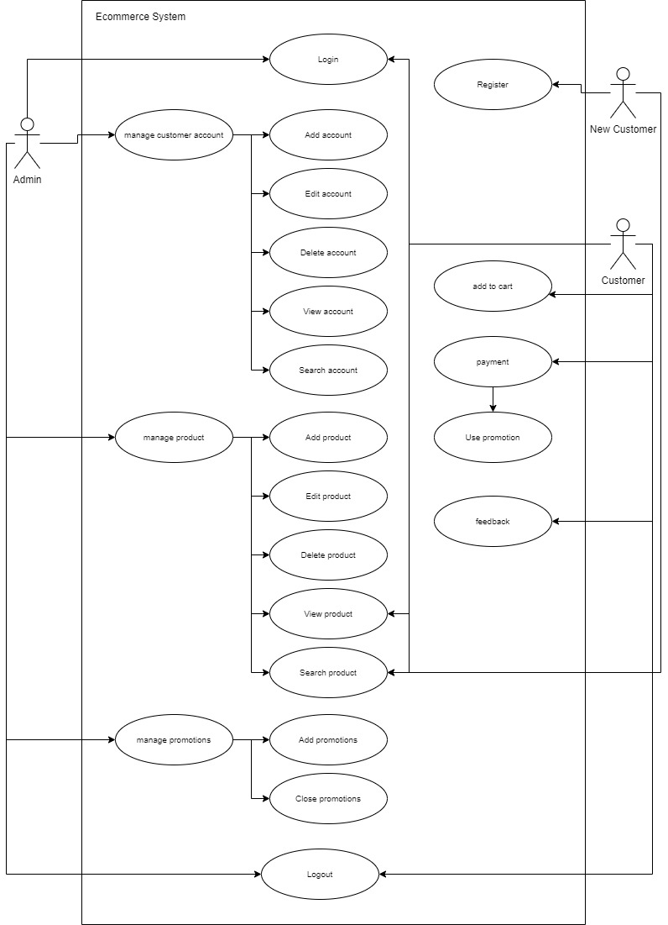

*Figure 1: Use Case*

**Admin**

* Admin has management on the system, so he can change any problem on the system.

**Customer**

* Customers can browse our site that have an interest in our products, they also can put the product in the cart that has prepared for them.
* As our customers we will do some promotion for them as a reward to be our customers.

**New Customer**

* For new customers they can browse our site, but they can purchase the product before register as our customer.

## **2.3 User Characteristics**

The users of the FICT include new customer, customer, and admin. Users should be familiar with terms such as login, registration, ordering system, such as purchase, shopping cart, checkout, etc., as well as familiar with the Internet. Editors should be familiar with terms like login and backend, such as adding or removing courses, price adjustments, etc.

## **2.4 User Documentation**

User documentation should be provided at the end of development. It should have the following content:

The system will have 2 roles such as administrator, and user.

* **Administrator:** As an administrator, this role allows (create, delete, and edit) to perform other administrative tasks (such as monitoring system operations, editing system configurations, etc.).
* **User:** As a user, this role can purchase his favorite courses in the system or can query the information of multiple tutors or download some notes.

## **2.5 Design and Implementation Constraints**

Some of the design and implementation constraints identified are listed below:

* Users are not allowed to register for more than three courses.
* User does not have any rights to edit any data in the system.
* User pays the application fees in CREDIT CARD or ONLINE BANKING or ONLINE PAYMENT to register for Course.
* Online Payment facility may be restricted if the university does not want this facility for some reason.
* This system does not support distributed database Facility.
* The system is limited to HTTP/HTTPS Protocols.

A user cannot register for a course if:

1. He/she did not pass the SPM and did not earn at least credit in any of the 3 subjects (including mathematics or any equivalent),
2. the user registered in the course exceeds the capacity of the classroom,
3. The course has a time conflict with other courses in the same term.

## **2.6 Assumptions and Dependencies**

Let us assume that if the user uses our website the following:

* If the number of people that register for the same course exceeds than the allocated size, then their registration will be canceled automatically by the institution.
* Another assumption that could affect the design is that the user will have adequate internet connection; this could affect the speed with which the interface communicates with the database.

So, this can both let the user understand our website system more. If the user with less computer experience may have a harder time.

# **3. Requirements Specification**

## **3.1 External Interface Requirements**

### 3.1.1 User Interface

The user interface for this website will have to be simple and clear. Most importantly, it must be easy to navigate, easy to understand and accessible. The color scheme should be appropriate to provide familiarity with the university and there should be no contrast issues.

* Admin can View, Edit and Delete everything on the product.
* User can View the whole information.

The following table shows the user interface:

|  |  |
| --- | --- |
| **Home** | **Blog** |
|  |  |

*Figure 2: Home Page Figure 3: Blog*

|  |  |
| --- | --- |
| **About** | **Academic Team Details** |
|  |  |

*Figure 4: About Page Figure 5: Academic Team Details*

|  |  |
| --- | --- |
| **Course Details** | **Product / Course Page** |
|  |  |

*Figure 6: Course Details Figure 7: Product / Course Page*

|  |  |
| --- | --- |
| **Contact** | **Login** |
|  |  |

*Figure 8: Contact Figure 9: Login*

|  |  |
| --- | --- |
| **Register** |  |
|  |  |

*Figure 10: Register*

### 3.1.2 Hardware Interface

* OS windows 10
* Hard disk 256gb
* RAM 4gb
* Processor: AMD Ryzen 5 3500X 6 cores

### 3.1.3 Software Interface

* Xampp
* FileZilla
* Infinity Free
* Joomla

### 3.1.4 Communication Interface

This project supports all types of web browsers. We are using simple electronic forms for purchase forms, registering accounts, etc.

## **3.2 Functional Requirements**

### 3.2.1 Register

|  |  |
| --- | --- |
| **Functional Requirement Id** | FR1 |
| **Requirement Title** | Register |
| **Requirement Description** | * Registered user enters username, password, reenter password and email. * Registered users click on the "Register" button. |
| **Business Rationale** | Allow registered users to buy courses and provide personalization features later. |
| **Exception Scenarios** | * If authentication fails, the user should be redirected to error Scenario's page showing "Username, password or email incorrect" message. |
| **Dependencies** | The User registers for an account on the Website. |

### 3.2.2 Login

|  |  |
| --- | --- |
| **Functional Requirement Id** | FR2 |
| **Requirement Title** | Login |
| **Requirement Description** | * User enters username and password. * User clicks on "Login" button. |
| **Business Rationale** | Allow users to buy courses and provide personalization features. |
| **Exception Scenarios** | * If authentication fails, the user should be redirected to error Scenario's page showing "Username or password incorrect" message. Maximum password retries allowed are 3 after which the account should be temporarily locked and request user to contact customer support. * The operation should also support first time user registration and forgotten username/password. |
| **Dependencies** | * FR1: Users should be registered. |

### 3.2.3 Search

|  |  |
| --- | --- |
| **Functional Requirement Id** | FR3 |
| **Requirement Title** | Search |
| **Requirement Description** | * User enters any' of these course attributes: Course name, course description, course keyword and clicks on "search". * The search function should retrieve the matching records from the course database. * Search results should be displayed in pagination format with configurable page size. * It should allow the user to add the course to shopping cart. |
| **Business Rationale** | Help users to discover the course. This will be supplemented by course recommendations to boost sales value in future. |
| **Exception Scenarios** | * Display "No course found" if no course matches the Scenarios criteria. |
| **Dependencies** | * FR1: Users should be registered. * FR2: Users should be logged in. |

### 3.2.4 Stop Loss Order

|  |  |
| --- | --- |
| **Functional Requirement Id** | FR4 |
| **Requirement Title** | Stop loss order |
| **Requirement Description** | * When a course purchase channel is full or deactivated, the administrator closes the channel. |
| **Business Rationale** | The administrator sets the course to close or open. |
| **Exception Scenarios** | * If an administrator closes a course, users cannot purchase the course. |
| **Dependencies** | * Admin should be logged in. |

### 3.2.5 Create and Update Course

|  |  |
| --- | --- |
| **Functional Requirement Id** | FR5 |
| **Requirement Title** | Create and Update Course |
| **Requirement Description** | * The administrator creates a new course. |
| **Business Rationale** | Users can view courses. |
| **Exception Scenarios** | * If an admin does not add a new course, users won't be able to see the new course appear. |
| **Dependencies** | * Admin should be logged in. |

### 3.2.6 View Course Information

|  |  |
| --- | --- |
| **Functional Requirement Id** | FR6 |
| **Requirement Title** | View Course Information |
| **Requirement Description** | * Users can view course details, duration, intake month, total course fee, course introduction, minimum entry requirements, career prospects. |
| **Business Rationale** | Users can view and understand the details of the course. |
| **Exception Scenarios** | * If the administrator doesn't add information, users can't view course details. * If the administrator does not update the latest information, users cannot see the latest information, only the old information. |
| **Dependencies** | * FR2: Users should be logged in. |

### 3.2.7 Create Promotion

|  |  |
| --- | --- |
| **Functional Requirement Id** | FR7 |
| **Requirement Title** | Create Promotions |
| **Requirement Description** | * Administrators create promotions and how long they last. * When a promotion is created, it is emailed to all users via the email address of the record. |
| **Business Rationale** | The administrator create the promotions and the time (duration). |
| **Exception Scenarios** | * If an administrator doesn't create a promotion within the specified time, it affects that users can't get a discounted price during the promotion. |
| **Dependencies** | * Admin should be logged in. |

### 3.2.8 Use Promotion

|  |  |
| --- | --- |
| **Functional Requirement Id** | FR8 |
| **Requirement Title** | Use promotion |
| **Requirement Description** | * Users can receive discounted rates when they claim vouchers during the promotion period. |
| **Business Rationale** | Users can purchase courses during the promotion period and enjoy preferential prices. |
| **Exception Scenarios** | * If the user does not receive the discounted price during the promotion period, the user can check whether the voucher has been claimed or whether the promotion time has ended. * After the promotion ends, users cannot get the discounted price. * If the user does not collect the voucher, the user will not be able to receive the discounted price. |
| **Dependencies** | * FR1: Users should be registered. * FR2: Users should be logged in. |

### 3.2.9 Shopping Cart

|  |  |
| --- | --- |
| **Functional Requirement Id** | FR9 |
| **Requirement Title** | Shopping Cart |
| **Requirement Description** | * The shopping cart function should display all the course added by user to the shopping cart. * While displaying the course, it should get the course availability from inventory system and course price from pricing system to display the availability and pricing information * It should allow the user to check out the course in shopping cart. |
| **Business Rationale** | Provide the online users with a seamless shopping experience. |
| **Exception Scenarios** | * If the selected course is not available, system Scenarios should not allow the user to check out that course. It should display appropriate error message. |
| **Dependencies** | * FR1: Users should be registered. * FR2: Users should be logged in. |

### 3.2.10 Checkout

|  |  |
| --- | --- |
| **Functional Requirement Id** | FR10 |
| **Requirement Title** | Checkout |
| **Requirement Description** | * The checkout function should display the course in the shopping cart and the registration information. |
| **Business Rationale** | Provide flexible options for users to purchase the course. |
| **Exception Scenarios** | * If there are no courses in the shopping cart or checkout function, the checkout payment procedure cannot be performed. |
| **Dependencies** | * FR1: Users should be registered. * FR2: Users should be logged in. * FR9: Users should have used checkout from shopping cart. |

### 3.2.11 Payment

|  |  |
| --- | --- |
| **Functional Requirement Id** | FR11 |
| **Requirement Title** | Payment |
| **Requirement Description** | * It supports the user to enter credit/debit card information to complete the transaction. Additionally, any other online payment also be supported. * Post successful payment, it should display the order information and send out a detailed mail to registered email account. |
| **Business Rationale** | Provide flexible payment options for users to purchase the course. |
| **Exception Scenarios** | * If the payment gateway is down, the system should display an appropriate error message. * If the credit/debit card account declines the transaction, an appropriate error message should be displayed and allow the user to retry the transaction. |
| **Dependencies** | * FR1: Users should be registered. * FR2: Users should be logged in. * FR8: Users should get a promotional price * FR9: Users should have used checkout from shopping cart. * FR10: Users should pay using the checkout function. |

### 3.2.12 Contact

|  |  |
| --- | --- |
| **Functional Requirement Id** | FR12 |
| **Requirement Title** | Contact |
| **Requirement Description** | * The user enters an email, Tel, name, subject, and message. * The user clicks the "Submit" button. |
| **Business Rationale** | Allow users to contact admin and provide feedback. |
| **Exception Scenarios** | * If the admin doesn't reply to the message or can't submit it, check to see if there's an error filling in the message. * If you want to send a message using a different way, the user can send the message using an email address, which can be found below. |
| **Dependencies** | * FR1: Users should be registered. * FR2: Users should be logged in. |

### 3.2.13 Logout

|  |  |
| --- | --- |
| **Functional Requirement Id** | FR13 |
| **Requirement Title** | Logout |
| **Requirement Description** | * User clicks on "Logout" button. |
| **Business Rationale** | Allow users to sign out of the account. |
| **Exception Scenarios** | * If the user needs to purchase a course, the user needs to log back into the user account to make the purchase. |
| **Dependencies** | * FR1: Users should be registered. * FR2: Users should be logged in. |

## **3.3 Non-Functional Requirements**

### 3.3.1 Performance Requirements

To maintain acceptable speeds within the maximum number of uploads allowed by a particular client, as any number of users can access the system at any time. Also, the connection to the server will be based on the user's attributes, such as his location, and the server will work 24x7 times.

### 3.3.2 Safety Requirements

A database may crash at any given time due to a virus or operating system failure. There needs to be a database backup to avoid database loss. Appropriate UPS/inverter facilities should be provided in case of power failure.

### 3.3.3 Security Requirements

* The system will use a secure database.
* Normal users can only read the information, but they cannot edit or modify anything except personal information and some other information.
* The system will have diverse types of users, each with access restrictions.

### 3.3.4 Software Quality Requirements

* There may be numerous administrators working on a project, each with the ability to make modifications to the system. Members and other users, on the other hand, are unable to make modifications.
* It is best if the project is open source.
* Maintaining the database's quality in this manner makes it incredibly user-friendly for all database users.

### 3.3.5 Business Rules

Business rules are anything that captures and enforces business policies and practices. Rules can enforce business policies, make decisions, or infer new data from existing data. This includes the rules and regulations that users of the system should follow. This includes project costs and discounts offered. Users should avoid illegal rules and agreements. Neither administrators nor members should violate the rules and regulations.